Neurodiversity and Puberty: A Needs Assessment
Emma Richardson, OTS
Colorado State University,
Department of Occupational Therapy
February 24th, 2026

Gaps in Sexual and Reproductive Health Education
- One size fits all curricula
  - Over emphasis on biological aspects
  - Ineffective teaching methods
- Communication barriers
  - Use of analogy & euphemism
  - Discomfort & lack of experience
  - Inconsistent information
- Limited opportunities
  - Gatekeeping
    - Social stigma & Bias
  - Reliance on others
  - Restricted information

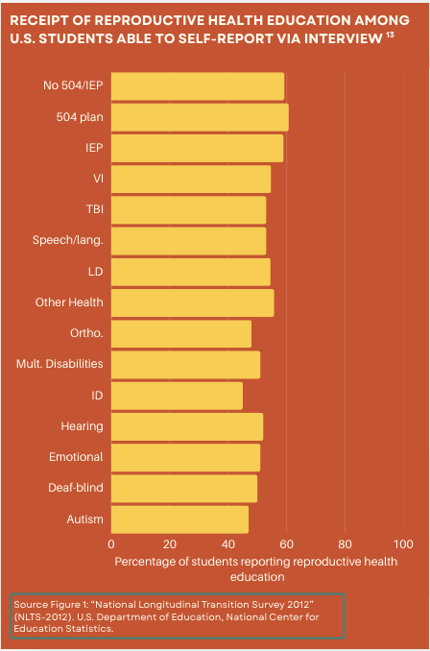

  - Speaker notes:
- Disabled and neurodivergent individuals are often excluded from puberty and sexual development education. NLTS-2012 data show that even self-reporting youth with disabilities receive less reproductive health education than their peers who aren’t getting SPED services.
- When ND youth do receive sex education the curricula is one size fits all and doesn’t address the unique needs of students with disabilities.
  - Curricula focus heavily on biology, ignoring social and emotional aspects of puberty. It’s often heteronormative and lacks representation of diverse gender and sexual identities.
  - Lecture based lessons present abstract concepts auditorily and opportunities to clarify misunderstandings through discussion or questions are limited.
- Communication barriers also decrease the quality of education being provided. Most adults lack experience and skills in discussing these topics with ND populations and tend to use non-literal language or euphemisms causing misunderstandings.
- Stigma and misconceptions surrounding sexuality for this population leads to avoidance of the topic all together.

Survey Results: Education and Support
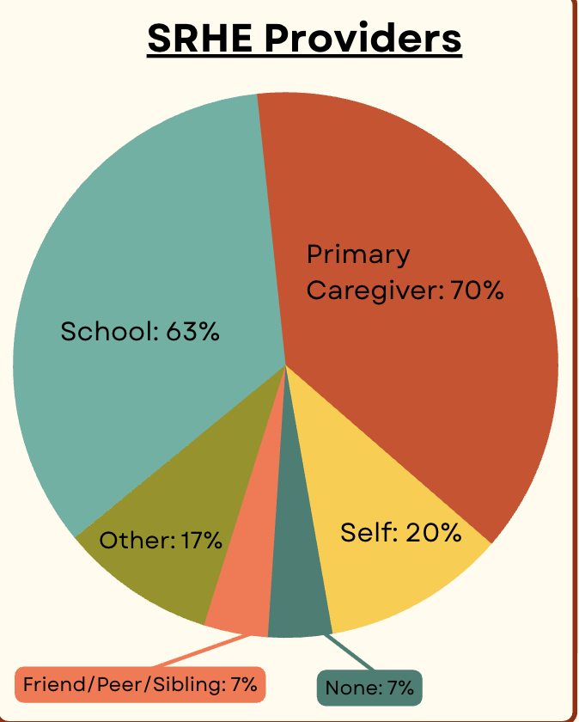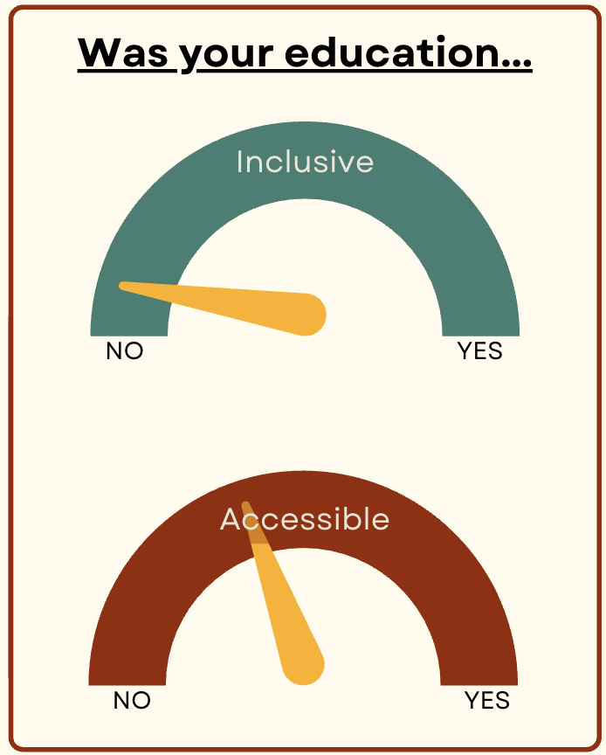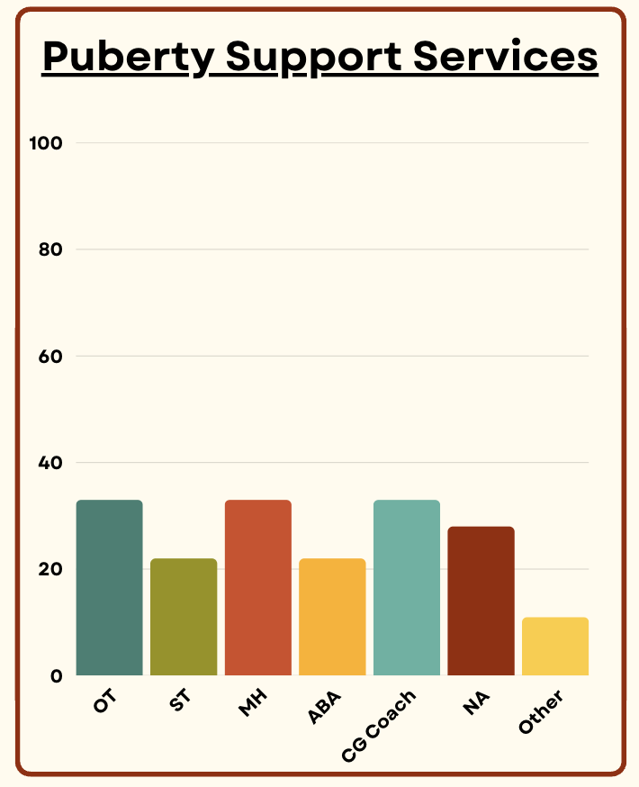
  - Speaker Notes:
- SRHE Providers: This first graph shows who provided the respondents with education on puberty and sexual development. The highest percentage was primary caregivers followed by school.
- Was your education… When asked if the education that they received was inclusive of disabilities and neurotypes and accessible to their learning style most said no to both.
- Puberty Support Services: The final graph shows the strategies parents and kids have used to manage puberty challenges. OT is most common, followed by mental health and parent coaching.

Survey Results- Support need comparison
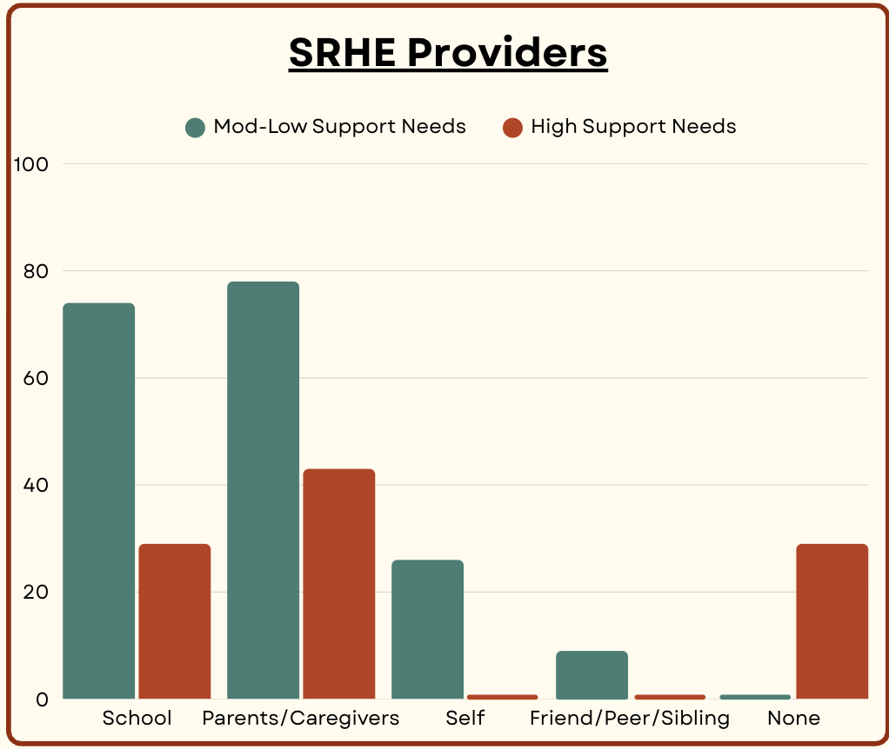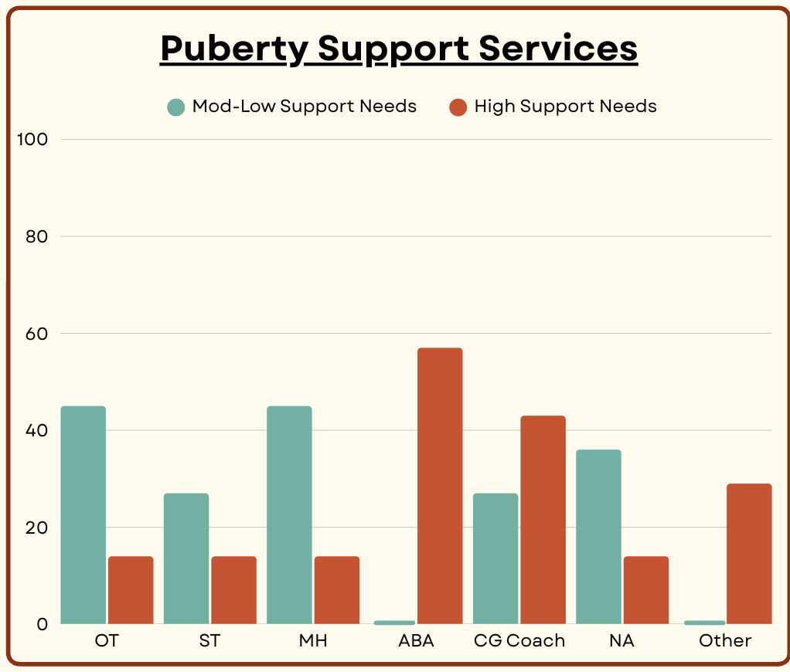
  - Speaker Notes:
- I also want to quickly compare the education and support that folks with high support needs are receiving compared to those with moderate-low support needs.
- This data indicates that folks with higher support needs or more complex disabilities are a lot less likely to receive education in school. Also, behavioral services were by far the most common intervention used amongst high support needs kids. On the other hand, lower support needs and higher masking folks are getting most of the education from school and a lot of parents did not think puberty concerns needed to be addressed at all in therapies.

Primary Puberty Related Challenges
- Sensory regulation
- Emotional regulation
- Menstruation
- Sexual behavior
- Safety
- Relationships
- Interoception
- Communication
  - Speaker notes:
- Now we will jump into the specific challenges for ND folks during puberty

Survey Results- Puberty Related Challenges
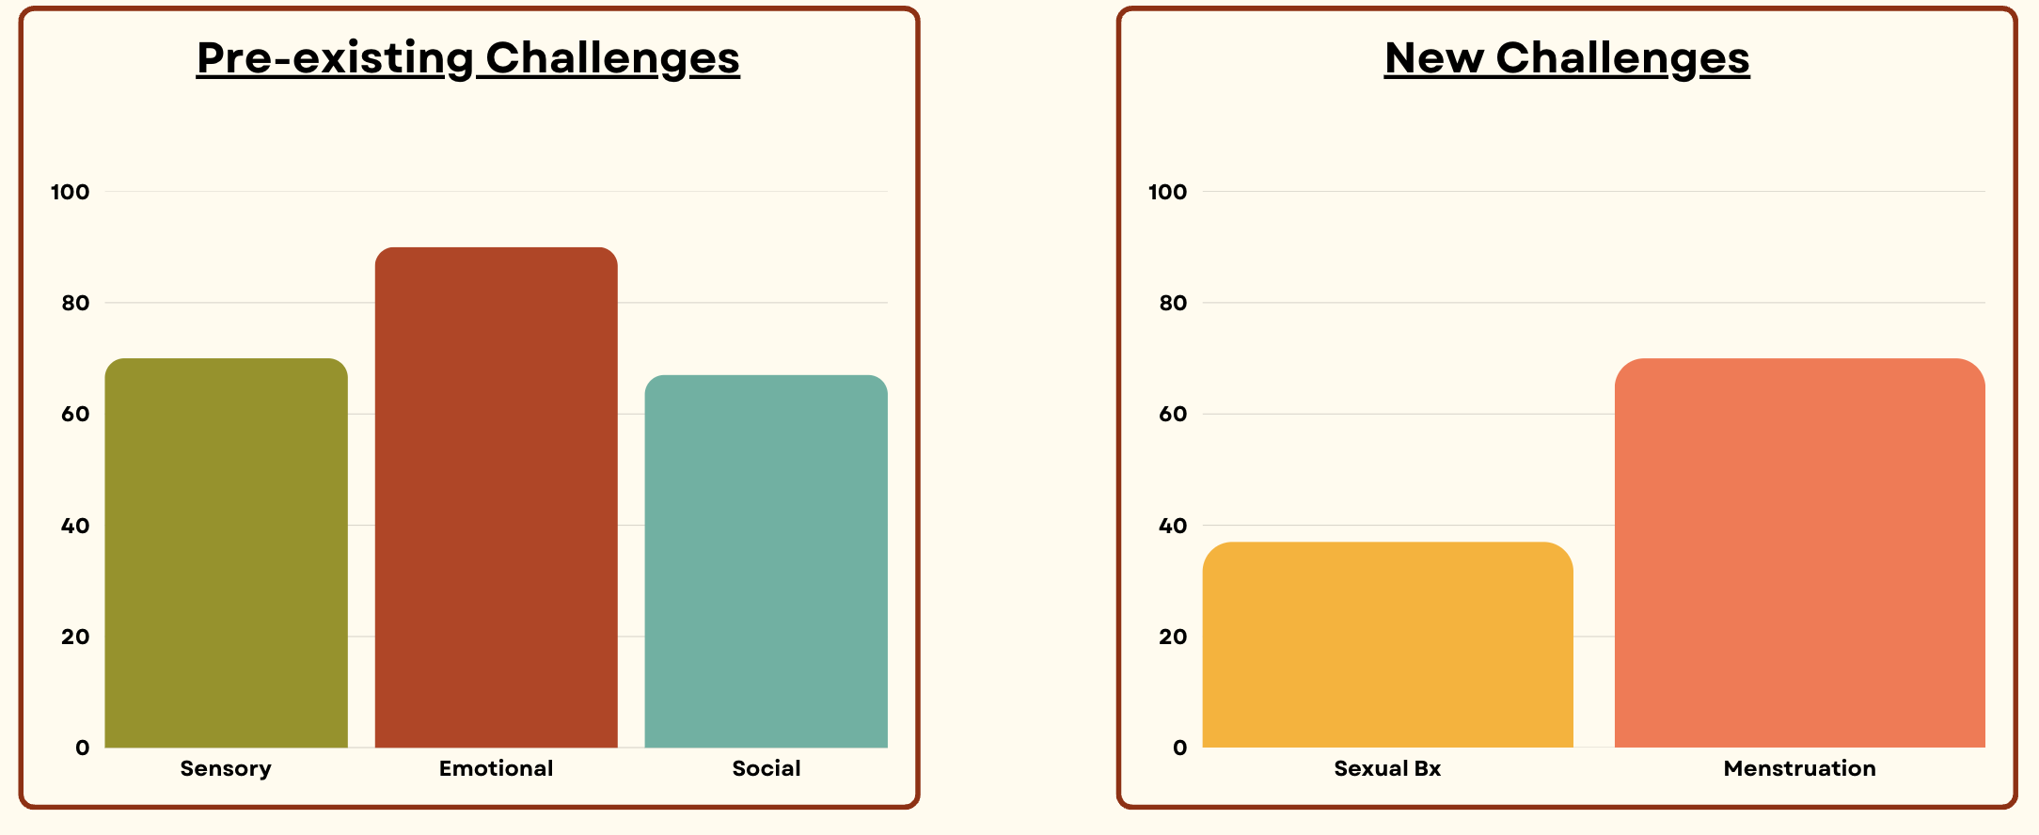
  - Speaker notes:
- Survey results indicated emotional regulation as the most common pre-existing challenge that was intensified by going through puberty.
- Menstruation difficulties were more common than challenges with sexual behavior.

Survey Results- Sensory Processing
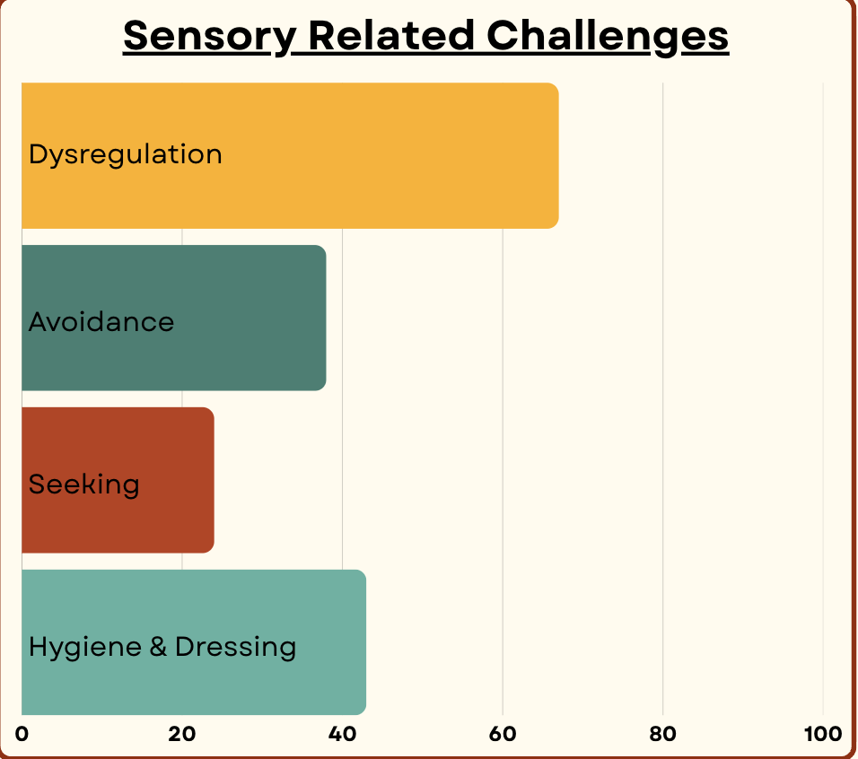
Quotes in thought bubbles:
- I feel like I need to remove all my skin when I’m PMSing
- Body hair feels weird but so does shaving...
- Puberty can intensify sensory processing issues
  - Speaker notes:
- Overall puberty seems to significantly increases sensory dysregulation. Respondents noted heightened sensitivities, avoidance, sensory seeking, and difficulties with hygiene and dressing due to sensory needs as sensory related challenges.

Sensory Processing
Heightened sensory challenges
- Greater sensitivities
- Increased seeking
- Intensified dysregulation
Dressing:
- Bras & binders
- New clothes
  - Style expectations
  - Growing
Hygiene
- Body odor
  - Showering
    - Genital hygiene
  - Deodorant
- Acne
  - Face washing
  - Treatments
- Body hair
  - Shave it? Wax it? Leave it?
Periods:
- Physical sensation
  - Wet
  - Products
- Smells

  - Speaker notes:
- Sensitivities to tactile input make new hygiene routines really challenging
  - Managing body odor is difficult since deodorant and showering can be overwhelming sensory experiences. Products that mask odor may not be suitable for smell-sensitive individuals. On the other hand, those under-responders to olfactory input might not notice or address odor at all.
  - Hormonal acne is common and regular face washing and using skin care products can be really overwhelming.
  - Body and pubic hair are tricky because the experience of your skin changing textures can be upsetting but hair removal can also be hard and confusing.
  - Genital hygiene is also a real challenge especially since almost no one is provided accurate information on how to do it at an appropriate age.
- Social expectations about clothing change during puberty and a lot of folks have to sacrifice sensory comfort to fit in or follow rules.
  - Growth spurts or outside judgment can force kids out of clothes they have considered safe for years.
  - Breast development alone can be uncomfortable, and adding bras or binders—especially if you haven't explored options—makes it worse.
- As far as periods, we will discuss them more later but basically, they tend to be a sensory nightmare for pretty much anyone who has one.

Survey Results: Emotional Regulation
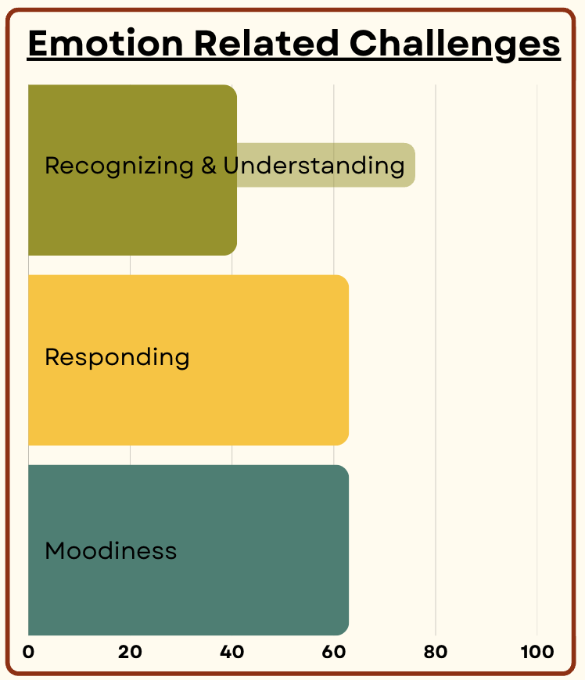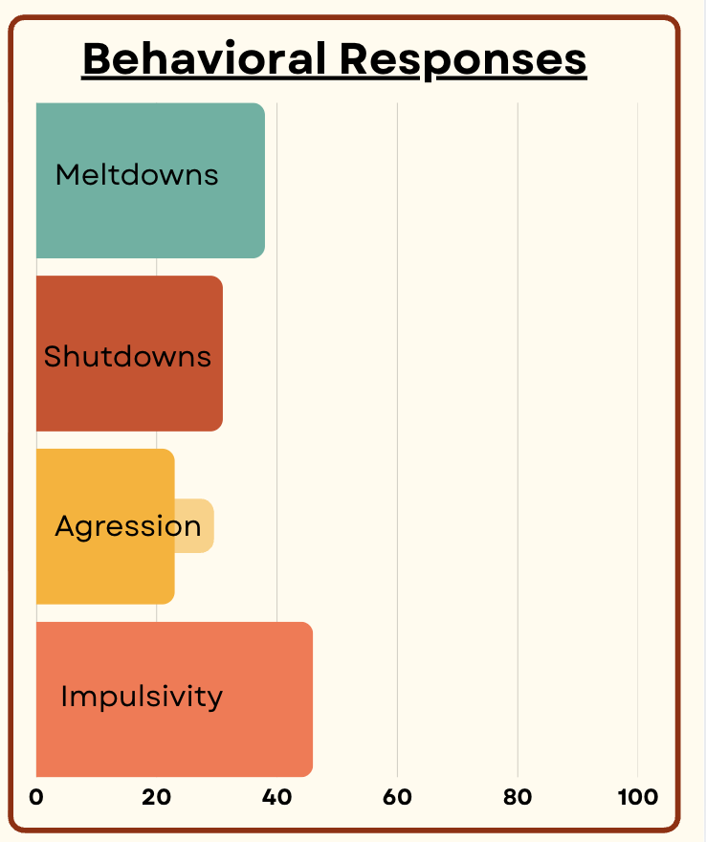

Quotes in thought bubbles:
- in a constant state of invisible dysregulation
- Emotional Regulation got harder in middle school
- It has gotten harder for him to deal with requests/demands and he responds with aggression
  - Speaker notes:
- Hormonal changes during puberty amplify emotional responses, trigger mood swings, and increase emotional dysregulation. People identified greater difficulty recognizing, understanding, and responding to their emotions, and experiencing heightened moodiness.
- Increased dysregulation was associated with an increase in shutdowns, meltdowns, aggression, and impulsivity.

Emotional Regulation
Emotional dysregulation:
- Anxiety
- Anger
- Mood swings
- Sensitivity
- Agitation
Misunderstanding & miscommunication
- Challenges recognizing & responding to mood swings
- Difficulty expressing emotions
- Misinterpretation of emotional experience
behavioral manifestation
- Impulsivity
- Distress
- Meltdowns
- Shutdowns
- Aggression

  - Speaker notes:
- Rising intensity and frequency of challenging emotions like anxiety, anger, irritability, along with rapid mood shifts and heightened sensitivity all contribute to general emotional dysregulation during puberty.
- Recognizing and responding to emotions is difficult when mood swings or hormones cause moodiness or dysregulation and there is no external trigger.
- Difficulty recognizing emotional cues can limit ability to communicate one’s experience and self-advocate, causing misinterpretations, and leaving support needs unmet.
- Difficulty in recognizing, communicating, and responding to emotions can lead to behavioral outbursts or withdrawal. Parents may not make the connection about these challenges and mistake mood swings for behavioral problems.

Survey Results: Social Connection
  - 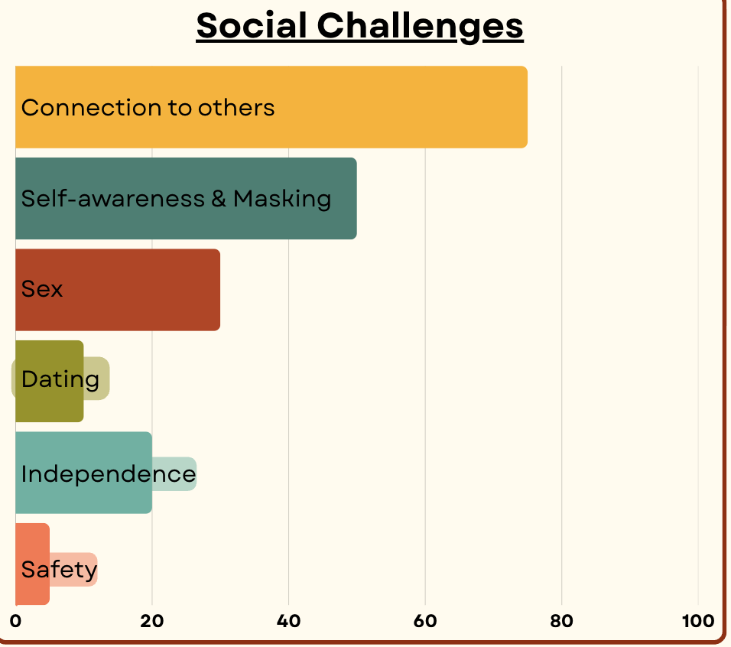
Quotes in thought bubbles:
- I didn't understand anything sexual when I found out I liked it.
- You know you're not normal and all you wanted was to be with a normal person
- anxious that other kids are making fun of him
- She is intensely focused on dating, sexual relationships
- I recognized my social differences and started intentionally masking for the first time

  - Speaker notes:
- Puberty brings numerous social challenges, with 75% of respondents citing difficulties in social connections as the most significant. Increased self-awareness and masking behaviors are also prominent. Challenges in independence, dating, and sex were noted, while safety issues were surprisingly absent contrasting with existing research.

Social Connection
Social context:
- Self-awareness
- Use of supports and accommodations
- Desire for connection vs. SPINS
Family:
- Lack of independence vs autonomy
- Communication and comfort
- Demand avoidance
Safety:
- Danger awareness and recognition
- Vulnerability to abuse and exploitation
- Risk of sexual disuse
Dating and sex:
- Social norms
- Non-verbal communication
- Boundaries and consent

  - Speaker notes:
- Puberty complicates social environments as adolescents develop their sense of self and notice how they differ from peers.
  - This often has a negative impact on self-esteem and individuals often begin masking and become more reluctant in using accommodations as they have a stronger desire for social connection and acceptance.
  - Special interests may become more important and intense which can create barriers in someone’s ability to connect with same age peers or participate in social activities they used to engage in.
- Puberty is also when many individuals become interested in dating and romantic relationships. Because there are so many complex social norms around dating and ND individuals lack social role models, it can be really challenging to understand what dating is supposed to look and feel like.
- Safety is a significant concern for this population as just having a disability increases your risk of abuse and exploitation. This risk is even more insidious with digital communication. Systematic barriers and widespread biases make reporting abuse extremely challenging. These barriers also increase the risk of sexual disease and delay detection of infection, pregnancy, and abuse.
- During puberty the most significant issue around sexual relationships is around boundaries and consent.
- Sexual relationships can be especially complicated for ND individuals. During puberty, the main challenges are boundaries and consent.
  - Many lack adequate education from school or parents, and social pressure for conformity pushes ND to ignore their own needs in order to please others.
  - Additionally, many have experienced boundary violations by trusted adults who used compliance-based approaches, leaving them unsure what consent actually means or how to set and enforce boundaries
- Puberty often affects the entire family. Parents of ND children frequently cite frustration over limited resources to support their child's transition. The push for greater independence challenges both overprotective parents and those with children needing more support than peers. Many also report increased demand avoidance and refusals, with one mother noting a rise in PDA-related pushback.

Survey Results: Sexual Behavior
  - 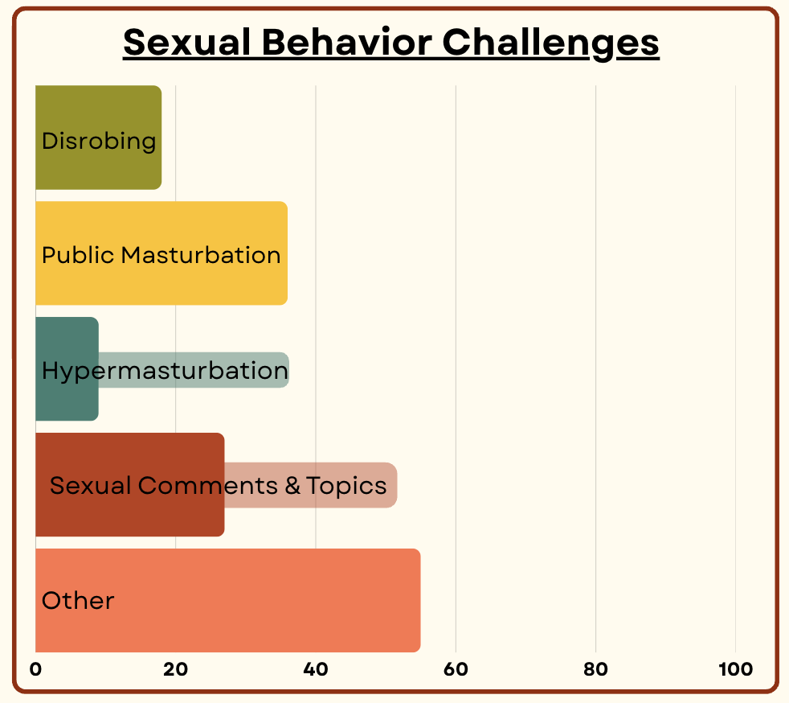
Quotes in thought bubbles:
- Public spaces are challenging for us, especially with inappropriate self-stimulation
- There is a gap in teaching about self-pleasure in a shame-free and developmentally appropriate way
- She talks a lot about period and personal areas in public loudly
- Initiating contact with girls he finds attractive and wanting to have physical contact
  - Speaker notes:
- Public engagement in sexual behavior is a common challenge for ND folks especially during puberty. Inappropriate masturbation and unwanted sexual advances were the most common challenges for this topic.

Sexual Behavior
- Disrobing
- Communication
- Masturbation
  - Hyper masturbation
  - Inappropriate contexts
  - Inappropriate objects
  - Inaccessible
- Consequences
  - Restricted community access
  - Legal ramifications
  - Injury to self
  - Harm to others
  - Social isolation
  - Speaker notes:
- Disrobing is a fairly common behavioral response for some ND people. Often the intention is not sexual but as kids grow into adult bodies the outcome of this behavior is often seen as sexual.
- Excessive public discussion of sexual topics and unwanted sexual comments or advances often stem from a lack of understanding about boundaries, consent, and social norms.
- Masturbation can also pose a challenge for a lot of different reasons.
  - Many individuals don’t have access to information to help them learn about what self-pleasure is and how to masturbate. Physical or cognitive differences may prevent someone from effectively masturbating without education and supports.
  - Other common issues include masturbation in public spaces, around other people and with inappropriate objects.
  - Additionally hyper masturbation- masturbation that occurs so frequently it causes physical harm or interferes with daily functioning can be a huge challenge. Excessive and inappropriate masturbation may be caused by a lack of information and understanding of public and private behaviors, sensory seeking, and even praxis issues.
  - Note: Equating masturbation or sexual activity solely with sensory-seeking behavior can invalidate the individual's experiences and needs.
- Supporting clients in managing inappropriate sexual behavior is crucial because the consequences and risks of these actions can be severe. However, negative reactions can foster shame around masturbation, hindering healthy sexual development so the approach needs to be really mindful.

Survey Results: Menstruation
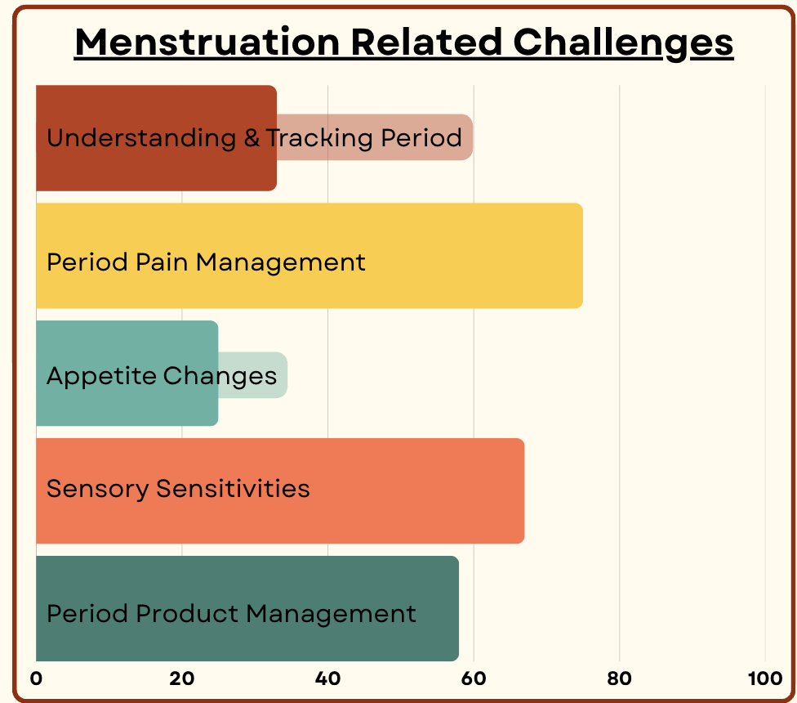
Quotes in thought bubbles:
- Doesn’t want to go anywhere on her period
- I would think about the smell and the feeling and needing to change so much I couldn’t focus.
- I thought using anything other than tampons was embarrassing
- Parents may misinterpret distress related to menstruation
  - Speaker notes:
- Periods are tough for most people, especially ND teens. The biggest challenges are managing pain and sensory issues, tracking cycles, and handling period products.

Menstruation
Lack of independence and negative impact
- Tracking cycle
- Isolation
- Period pain
- Managing products
- Routine disruption
- Sensory sensitivities

  - Speaker notes:
- Menstruation negatively affects the well-being of ND adolescents who face heightened sensory and emotional challenges. Non- and minimally speaking individuals often experience even greater agitation and distress.
- Sensory experiences around menstruation are often heightened for ND individuals, with increased sensitivities during PMS and periods. Period products and the physical sensations of menstruating can trigger sensory dysregulation.
- Managing period pain is challenging, especially for those with communication or interoception difficulties. Difficulty distinguishing it from digestive issues can hinder effective management and treatment.
- Understanding your hormone cycle and its impact on your brain and body is difficult without proper education. Tracking periods is challenging, and their natural variability can disrupt routines and cause stress. Without a predictable cycle, PMS-related symptoms become confusing, leaving you uncertain and uncomfortable.
- Managing period hygiene can be difficult due to sensory challenges, motor skills, and lack of education about available products. Social expectations also influence product choices, adding to the challenge.
- Many ND individuals need significant support to manage their periods. This lack of independence can be difficult, especially when comparing themselves to peers or expectations.

And on top of all that… Compounding Challenges
- Communication
- Interoception
- Praxis
- Executive function

  - Speaker notes:
- I have noticed that challenges with communication and interoception have a significant impact on all of the areas that make puberty especially hard for ND adolescents.
  - Understanding your body, communicating about sex, and advocating for yourself are crucial for managing puberty. Being aware of signals, their origins, and how to respond is equally important.
- Challenges with praxis and executive function make a big difference in our ability to mentally and physically manage all of the changes that come with puberty.

What now? Managing Puberty & Supporting SRHE
- Neurodiversity-affirming education
- Trauma informed approaches
- Holistic and client centered interventions

- Specialized training and collaboration
- Tailored curricula
- Beyond biology and toward taboo topics
- Multi-sensory learning and accommodations
- Communication access

  - Speaker notes
- We must prioritize neurodiversity-affirming, trauma-informed, and individualized holistic care when supporting ND individuals during puberty.
- Anyone providing sex education to ND individuals should understand ND learning and communication styles and know how puberty can affect this population.
  - We should encourage collaboration between all team members to minimize confusion and misinformation.
  - We should provide information about the social and emotional aspects of puberty and opportunities to learn about topics that may be considered taboo.
  - We should use multi-sensory and accessible approaches when providing education. Structure, visual aids, and physical demonstrations are all beneficial tools.
  - We should create spaces where anyone regardless of age, neurotype, etc., feel comfortable asking questions and seeking information.
  - We also must ensure that that non and minimally speaking individuals have access to the words needed to talk about puberty and sexuality.

Thank you for participation
Please scan the QR code or click here to share your top topic priorities for interventions and resources.


References
Please scan the QR code or click here to find the references page for this presentation.



